Advantages
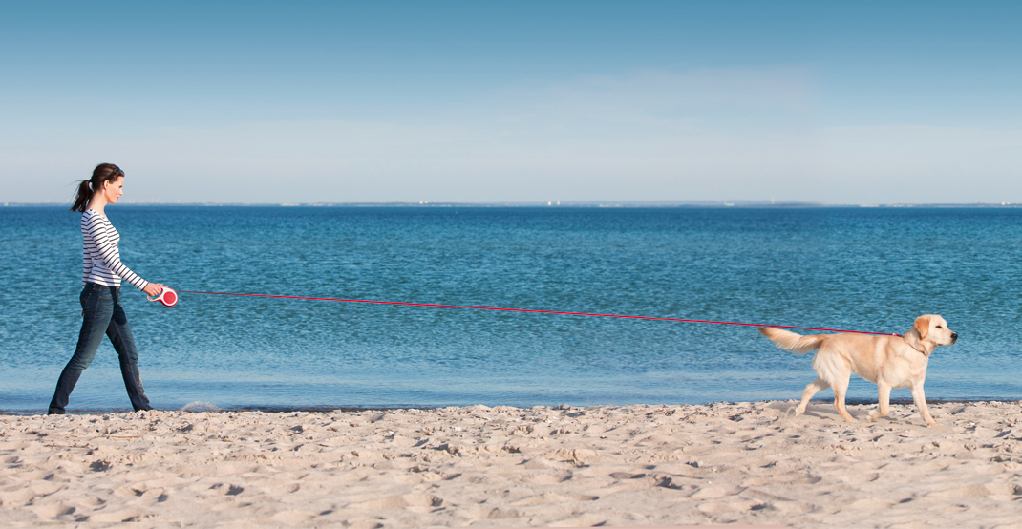
flexi retractable leashes unite two diagonally opposed requirements; they let you walk your dog in a controlled way while giving your best friend freedom of movement to discover his immediate environment. flexi is the ideal bond between you and your best friend and will bring you much joy.

The flexi Principle

Freedom for you and your dog
flexi retractable leashes never slacken as they are always subject to slight tension. With the help of the integrated braking system you are always able to guide and command your dog. By pushing the brake button with your thumb and a slight pull on the leash you give your dog short orders or lead him back to you. An additional permanent stop function allows you to fix the flexi leash at a certain length. More information is included in the instructions for use.

Quality
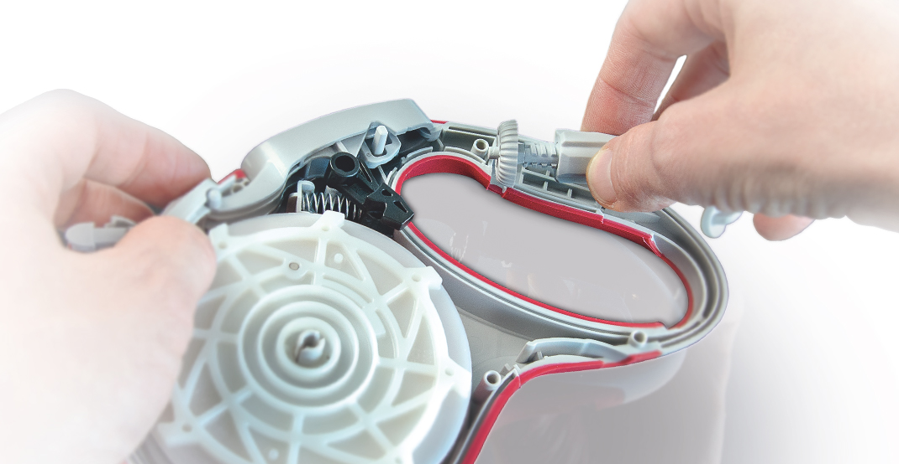
flexi leashes comply with the highest quality standards and are manufactured in Germany. Each leash is assembled by hand and undergoes several quality checks before it leaves our factory. This is how we generate top products – Made in Germany.

Care Instructions
If the flexi leash (cord or tape leash) gets wet, please pull it out of the case completely, activate the brake lock, and let it dry overnight. Remove adherent dirt from tape/cord and casing before you retract the leash. Strong abrasion or damages - often caused by bites - can harm cord or tape. Please do not continue to use a flexi leash in such a case.

Special Precautions
A copy of the Special Precautions & Directions booklet is included in every leash packaging.
Download safety instructions:
for cord leashes
for tape leashes
for VARIO leashes
Read the special precautions below before using a flexi leash.
Failure to follow these safety precautions can result in serious injury.
Because this leash is retractable, it requires special precautions to reduce the risk of injury. Read this pamphlet before using your leash and save it for future reference.
Who can use this leash?
This leash should only be used by responsible people who have read and can follow all of these precautions. Anyone who uses this leash must be able to control the dog and watch the dog closely at all times to keep it from running off or wrapping anyone in the cord/tape/belt. Keep out of reach of small children. Never let anyone play with this leash.
Is this leash right for your dog?
- Do not use this leash with a disobedient or uncontrollable dog, since they are more likely to wrap the cord/tape/belt around people or to run off at high speeds.
- Only use this leash with a dog that does not exceed the weight limit listed on the leash.
- Leashes for larger dogs have a tape or belt instead of a cord to reduce the risk of amputations and cuts.
- Even small dogs can pull hard enough to injure you, particularly because the length of the leash allows dogs to run and build up speed. Follow all of these precautions even with a small dog.
Use this leash only as intended.
- Follow the “Directions” section in this pamphlet.
- Never attach more than one dog to the leash. Never use more than one flexi™ leash at a time.
- Never attach any accessories to the leash housing unless they are sold or approved by flexi™.
Cuts & Burns
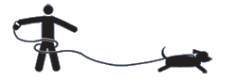
If the cord runs across your skin, it can cause abrasions (like a rope burn) or severe cuts. Cuts and burns are more likely if the cord/tape/belt wraps around any part of the body. Avoid contact with the cord/tape/belt and never let it wrap around any part of your body.
- Avoid contact with the cord/tape/belt and never let it wrap around any part of your body.
- Do not allow slack to build up in the cord/tape/belt– you might get tangled in the slack.
- Do not touch the cord/tape/belt if the cord/tape/belt wraps around you. Turn around or pass the handle from one hand to the other to unwrap yourself. (See “Finger Amputation and Fractures”)
- If you want to further reduce the risk of cuts and burns, you can wear long sleeves and pants to protect your arms and legs.
Finger Amputations & Fractures
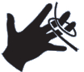
If the cord/tape/belt wraps around fingers or catches on a ring, a hard pull on the leash can amputate fingers or break bones.
- Avoid touching the cord/tape/belt when the leash is attached to your dog and never let the cord/tape/belt wrap around hands or fingers.
- Do not hold the cord/tape/belt.
- Do not grab the cord/tape/belt to control your dog.
- If the cord/tape/belt gets entangled in a bush or other object, gain control of your dog before disentangling it. Do not touch the cord/tape/belt if your dog can pull on it. If you want to further reduce the risk of finger amputation and fractures, you can take off any rings and wear sturdy gloves.
Eye & Face Injuries
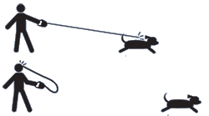
If the leash or your dog’s collar breaks, or if the leash disconnects from your dog’s collar, the cord/tape/belt and hook can snap back with enough force to cause serious eye damage, broken teeth, cuts, and bruises. If the cord/tape/belt is under enough tension, this can happen even when the leash is locked.
- Follow instructions for inspecting, attaching and detaching the leash in the “Directions” portion of this pamphlet.
- Tighten the safety collar around your dog’s neck and attach the hook to your dog’s regular collar. The safety collar prevents snap-back if the dog’s collar or the hook breaks, or if the leash disconnects from your dog’s collar.
Falls
Because the flexi™ leash is longer than regular leashes, your dog can build up more speed and pull on it harder, possibly pulling you to the ground.
- If your dog starts running away from you, immediately press the brake button to keep your dog from building up too much speed. If your dog has already built up speed, you will be pulled when you hit the brake or if the dog reaches the end of the leash.
- Do not allow slack to build up in the cord/tape/belt – your dog may run and build up speed until the slack runs out, suddenly pulling you.
- Have secure footing. Do not use the leash while on wheels (for example, a bike, skateboard or roller blades).
Injuries to Bystanders
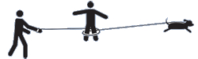
Bystanders are at risk of all of the injuries described in this pamphlet. In particular, they can be cut by the cord/tape/belt if they contact it or if it wraps around them. They might also trip on the leash.
- Be aware of bystanders. They might not notice the cord/tape/belt. Control your dog and keep the cord/tape/belt away from them.
- When around other people or animals, shorten the leash and keep your dog at your side with the leash locked.
- Avoid using the flexi™ leash near small children, including children in strollers.
- If the cord/tape/belt gets wrapped around someone, tell them not to touch the cord/tape/belt. Gain control of your dog and do not touch the cord/tape/belt if your dog can pull on it.
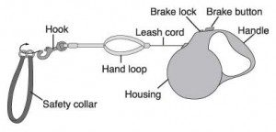

Directions
Inspect Your Leash & Collar Before Each Use
Make sure that all parts of the leash and your dog’s collar are in good condition and are not damaged, frayed, or broken.

Attaching the Leash & Safety Collar
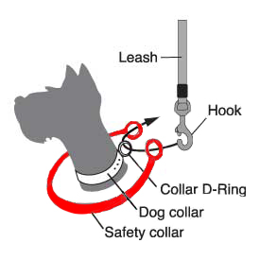
- Always use the enclosed safety collar in addition to your dog’s collar as illustrated. The safety collar prevents snap-back if the dog’s collar breaks, or if the leash disconnects from your dog’s collar.
- Attach the hook of the leash to the D-ring of your dog’s collar. Never attach it to your dog’s ID tag ring. That ring is not strong and will break.
- Make sure that the hook is fully closed and securely attached to the collar D-ring and the rings of the safety collar.
Detaching the Leash
Make sure your dog is under control. Fully retract the leash before detaching it.

Drying Instructions
If your leash gets wet, pull the cord/tape/belt out of the leash housing as far as it will go and lock the brake. Leave it to dry overnight in a place that is out of reach of children. When the cord/tape/belt is dry, carefully and slowly retract the leash to keep it under control.

Using the Leash
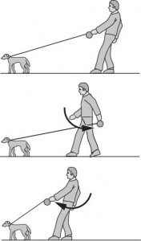
Always hold the leash by the handle, never by the cord/tape/belt You can also hold the hand loop with your other hand for extra control. Never tie leash around a tree, pole, or any other object.
To bring your dog nearer, follow these steps and never touch the cord/tape/belt:
- Extend your arm forward and press the brake button.
- Step toward your dog and at the same time bring your arm to your side.
- Release the brake button and swing your arm towards the dog and press the brake button again.
- Repeat as needed.

Repairs
Do not attempt to repair this leash. Do not open the leash housing. The leash housing contains a pre-wound spring that can cause injury if opened. See Limited Warranty. Opening the housing will void the limited warranty.

